# 

POC

(Automation Triggering mechanism)

Contents

Document Revision History ii

1 Design Approach 1

1.1 Purpose 1

1.2 Existing Process 1

1.3 Problem identified 1

1.4 Process changes after implementation 1

1.5 Impact on nightly batch 1

1.6 UC4 Scheduling 1

2 Introduction 2

3 File structure 3

3.1 File Structure 3

4 Poc_environment Configuration 5

4.1 File permission Setup 5

4.2 Mail Server Setup 5

5 Process Description 6

6 Execution steps: 7

6.1 Step 1 7

6.2 Step 2 7

6.3 Step 3 7

# Document Revision History

|  |  |  |  |
| --- | --- | --- | --- |
| **Version** | **Date** | **Modified By** | **Comments** |
| v0.1 | 04/04/2018 | Devesh Kumar Shrivastav | Initial Draft |
| v0.2 | 12/04/2018 | Devesh Kumar Shrivastav | Code change |
|  |  |  |  |
|  |  |  |  |
|  |  |  |  |
|  |  |  |  |
|  |  |  |  |
|  |  |  |  |

# Design Approach

## Purpose

There is a requirement to verify the correct loading of daily SOH inventory data from RMS source tables to RA target tables in Hot Topic. The purpose is to automate the comparison of SOH inventory data in RA and RMS tables by store and brand.

## Existing Process

This validation process has been done by executing queries manually in RMS and RA in the past.

## Problem identified

The manual work may lead to some human errors, so to avoid those we are automating this process.

Proposed Solution

Since this is a daily task, automation script has been developed for this purpose. This script will mail the before and after batch execution comparison output files to the respective persons.

## Process changes after implementation

## Impact on nightly batch

NA

## UC4 Scheduling

|  |  |
| --- | --- |
| **Module Name** | Daily Validation Automation SOH - Before |
| **Script name** | Poc_Internet_soh.ksh and poc_environment.ksh |
| **Schedule** |  |
| **Prompts** |  |
| **Condition** | After the RMS Apps are down |

|  |  |
| --- | --- |
| **Module Name** | Daily Validation Automation SOH - After |
| **Script name** | Poc_Internet_soh.ksh and poc_environment.ksh |
| **Schedule** |  |
| **Prompts** |  |
| **Condition** | Before the RMS Apps are up and after the job ***INVILDSIL*** completes**.** |

# Introduction

The functionality of this automation script is to compare the SOH (Stock on Hand) in RMS and RA before and after the nightly batch executes on the basis of store and brand. This automation script excludes the today’s adjustment as this mismatch will be adjusted in next nightly batch.

There are two *KSH* files associated with this automation script.



The *poc_environment.ksh* is used to set the variables for the execution of the automation script. The *poc_Internet_soh.ksh* is the script that performs the actual validation.

The output validation files after execution of the automation scripts are generated as in the samples attached below.

The sample for before snapshot:



The sample for after snapshot:



These output comparison files are automatically mailed to the respective parties.

# File structure

**$MMHOME/soh_validation**

* Before snapshot csv
* After snapshot csv

RMS SERVER

RA SERVER

**Linux System**

**$MMHOME/poc_internet_soh**

* poc_environment.ksh
* poc_internet_soh.ksh

DBLINK to fetch the data

DBLINK to fetch the data

## File Structure

The validation scripts (*poc_environment.ksh* and *poc_Internet_soh.ksh*) are placed inside the ***poc_Internet_soh*** folder in location $MMHOME. The output files generated are placed inside the ***soh_validation*** folder in location $MMHOME. The output files are generated on a daily basis and saved for future reference.

The naming convention for the output files are discussed here.

* before_file_name="Before_SOH_Validation_by_Department_Store_Inventory_Comparison_RA_vs_RMS_$date.csv"
* after_file_name="After_SOH_Validation_by_Department_Store_Inventory_Comparison_RA_vs_RMS_$date.csv"

The contents of the output files are discussed in this section.

* **Before Snapshot:**

Before snapshot contains the following comparisons:

* + - Comparison by store and brand.
    - Comparison by brand.
* **After Snapshot**

After snapshot contains the following comparisons:

* + - Comparison by store and brand.
    - Comparison by brand.
    - Discrepancies that were found for the departments and items due to today’s adjustments in RMS.

# Poc_environment Configuration

## File permission Setup

The automation scripts (*poc_environment.ksh* and *poc_Internet_soh.ksh*) that are placed under location *$MMHOME/poc_Internet_soh* needs to be provided with read, write and execute permission i.e (*chmod 777*)*.*

## Mail Server Setup

Firstly, we need to configure the SMTP mail server to send the mail containing the daily validation to the respective persons.

# Process Description

We need to execute the *poc_Internet_soh.ksh* for generating the *before* and *after* validation files only after properly configuring the poc_environment. This will generate two output files in *$MMHOME/soh_validation.*

The validation scripts will run the queries in the RA server. The tables in RMS server are accessed in RA Server for validation using DBLINK.

The expected time to generate the *before* and *after* validation output file is shown in table below.

|  |  |  |  |
| --- | --- | --- | --- |
|  | Comparison | Time taken (approximate) | Total  (approximate) |
| Before validation file | Comparison by Store and Brand | 3 minutes | 12 minutes |
| Comparison by Brand | 9 minutes |
| After validation file | Comparison by Store and Brand | 3 minutes | 13 minutes |
| Comparison by Brand | 9 minutes |
| Discrepancies | 1 minutes |

After the generation of these output files, these files are automatically mailed to the respective parties as shown in sample below.

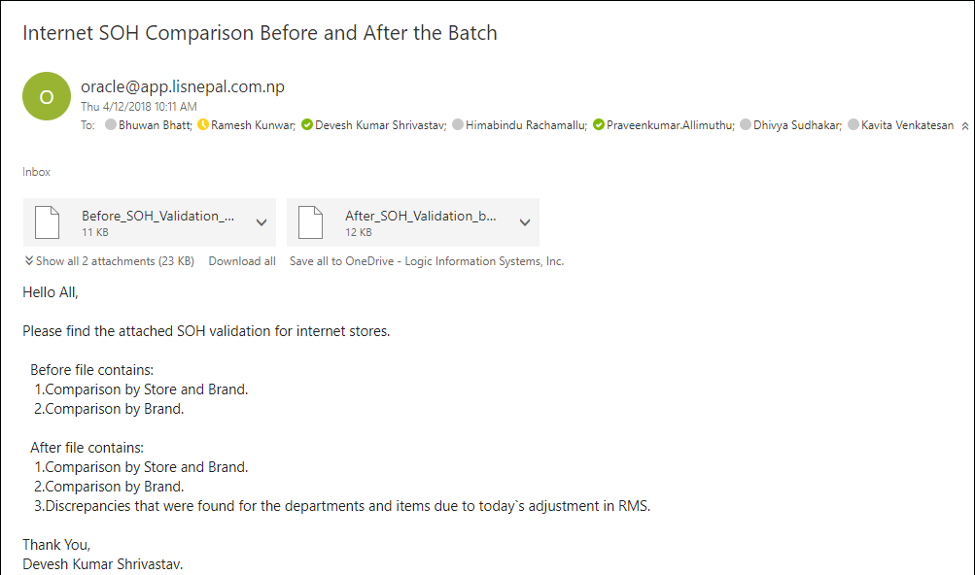

# Execution steps:

## Step 1

**After the RMS apps are down**, run the *poc_Internet_soh.ksh* to generate the CSV file for the before snapshot in location *$MMHOME/soh_validation.*

The before snapshot includes **comparison by Store and Brand for RA and RMS** and **comparison by Brand for RA and RMS**.

## Step 2

**Before the RMS apps are up and after the completion of job *INVILDSIL* of the nightly batch**, run the *poc_Internet_soh.ksh* to generate the CSV file for the after snapshot in location *$MMHOME/soh_validation.*

The after snapshot includes **comparison by Store and Brand for RA and RMS** and **comparison by Brand for RA and RMS** and **discrepancies**.

## Step 3

Auto triggering of the email with attachments sends the mail to the respective persons.

Flowchart:

Execute the poc_internet_soh.ksh for after comparison file and mail trigger.

Before the RMS apps are up.

(job ***INVILDSIL*** should be completed)

Wait for RMS apps to be down.

Execute the poc_internet_soh.ksh for before comparison file.

Note:

1. It should be strictly noted that execution sequence and timing is of critical importance for generating the before and after comparison output files to properly set the poc_environment variables.

Step 1 must be executed at the provided sequence i.e. immediately after the RMS apps are down.

Step 2 must be executed before the RMS apps are up and after the completion of job INVILDSIL of the nightly batch. Step 1 must have already completed before Step 2 can be executed.

1. The cause for discrepancies in RA vs RMS after validation file arises due to today’s adjustment in RMS. However, if the discrepancy arises due to any other reason the RA team should be contacted for analysis.

In the execution of the automation script, backup tables are created and dropped. The CSV files generated are placed in the relevant folder structure ($MMHOME/soh_validation). Date is included in the naming convention of the CSV files for future reference.